**Report about performance testing of localhost**

**1. Purpose:**

To investigate the working of localhost under different levels of load using QA Pro REST App.

**2. Tasks:**

* To assess server workability
* To determine maximal level of throughput
* To discover weak points of server

**3. Investigations:**

**1) Test 1 (Not many users, many transactions)**

1. Thread group — default. Threads (users) count — 1000

2. Ramp-up period — 10 sec

3. Duration — 180 sec

4. Performed requests:

* GET
* POST
* PUT
* DELETE

5. Test results:

1. Stable transactions throughout in range of 8-10k. No errors detected.

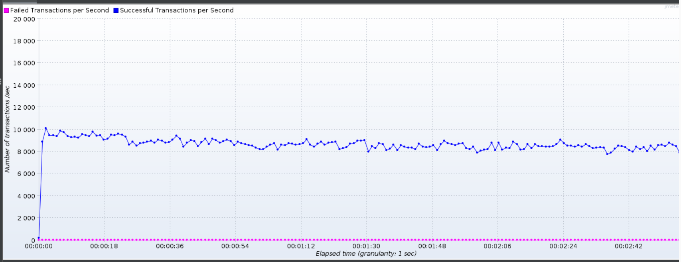

1. Stable low response time for requests except few separate transactions with long response time.

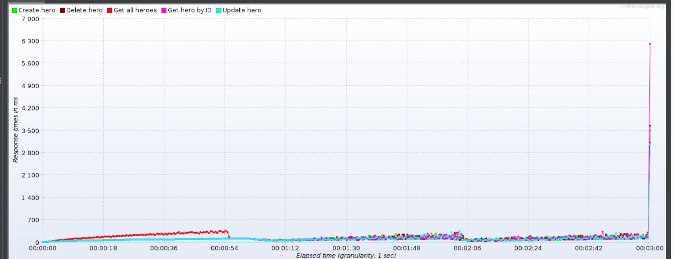

**2) Test 2 (Many users, many transatcions)**

1. Thread group — default. Threads (users) count — 10000

2. Ramp-up period — 10 sec, Duration — 180 sec

3. Loop Count — Infinite

4. Performed requests:

* GET
* POST
* PUT
* DELETE

5. Test results:

1. Detected consequential degradation of performance until server was finally broken.

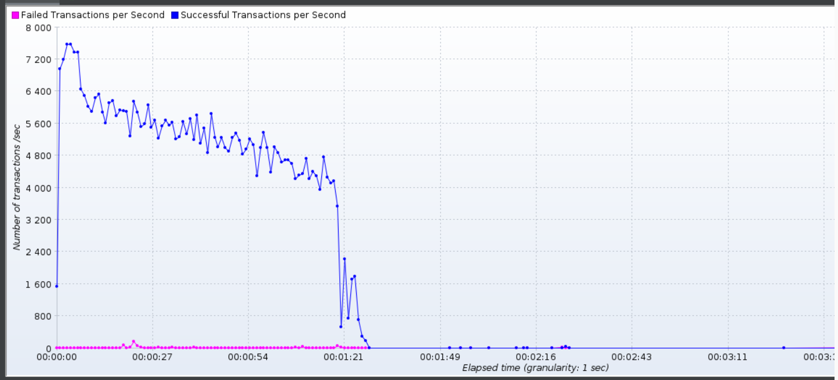

**3. Results and recommendations:**

1. To make a research if investigated level of transactions **8-10k** per second is accepted to your website.

2. To make a research about count of expected users simultaneously and actively working on your website and stabilize it if count is close or more than **10k**